**WORD DOCUMENT OF THE BLOG CONTAINING ALL DATA PROVIDED IN THE BLOG**

Well! This Covid-19 has reached to extreme level. Which is a highborn pain for each and everyone. Am i right or am i right? Each and every individual is effected to some level, of course some are effected more than the others. As the stress or sprain of the virus is spreading very swiftly, world is getting in the center of unpleasant pandemic in the current history. Corona Virus which is started from Wuhan, China in December 2019, the number of cases are getting increase in every single minute all around the globe. And so! this silently attacked virus have been also spread in Pakistan.

In the **Article**I'm going to share my work or Data Visualization for Covid-19 Pakistan. Dataset I have used for the project is taken or fetched from the Kaggle(URL: [https://www.kaggle.com/mesumraza/corona-virus-pakistan-dataset-2020#COVID_FINAL_DATA.xlsx](https://www.blogger.com/blog/post/edit/4862903634581934952/940037588416177731) ). Dataset has been updated there time by time but my dataset is from March 11, 2020 to May 5, 2020.

I have done my work in **Power BI**. Power BI is an amazing tool to solve ones problem at hand it does not require any difficulty or any difficult thing to make visuals. It helped me to make my COVID-19 visuals easily by its all over amazing features. And the good thing about Power BI i like is that it provides a Q&A feature through which one with the little know-how can easily extracts the required data from the visual.

I have made **10 Visuals, 3 Dashboards** to represent my data. I will show and explain briefly about all the visuals but firstly I will tell about **Data Cleaning** I have done. 

**DATA CLEANING:**

I have cleaned my data in Power BI by transforming data option available in the tool. Following are the things i have done to clean my data:-

* Renaming of all the columns names of all the tables in the data.
* Removing of errors from the columns.
* Removing of null or NaN from the data and replaced it by the value zero (0).
* Changing the data types of some of the columns.
* Replacing the concatenated or Joined line by line feed (to move the other sentence/line to the next line).
* Removing the extra null row by keeping the top rows.
* Transforming column to capitalize each word.
* Made a one to many relationship between two columns of different tables.

**DATA VISUALIZATION:**

I have provided all the 10 visuals (**BOTH INTERACTIVE and STATIC**) below with some explanation, and also provided the short video.

**VISUALIZATIONS:**  
Following are the 10 visuals shown statically and interactively is also shown below:-

**1.**    Highest cumulative case in specific region with respect to date.

[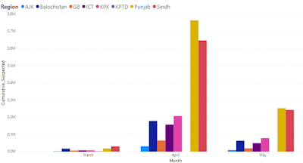](https://www.blogger.com/blog/post/edit/4862903634581934952/940037588416177731)

Shows in which region and month the case was highest and it shows the month May and region Punjab (can see an interactive result below).

**2.**    Regional statistics of total positive cases from the test cases performed.

[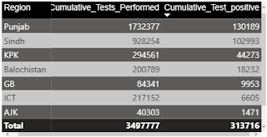[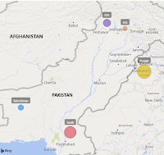](https://www.blogger.com/blog/post/edit/4862903634581934952/940037588416177731)](https://www.blogger.com/blog/post/edit/4862903634581934952/940037588416177731)

This visual shows the total number of positive test cases from the total test cases performed in each province (both spatial and summary visuals shown above)

**3.**    Total deaths, still admitted and the recovered cases across each region.

[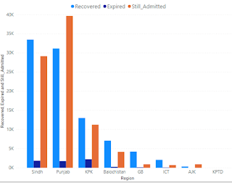](https://www.blogger.com/blog/post/edit/4862903634581934952/940037588416177731)

This visual shows the total number of deaths, admitted and recovered in each province.

**4.**    Foreign and local transmission(Iran & Tableegh) and their percentages across the Provinces.

[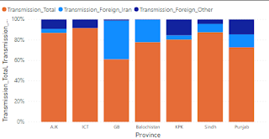](https://www.blogger.com/blog/post/edit/4862903634581934952/940037588416177731)                                       [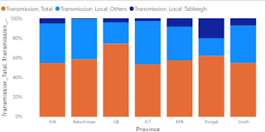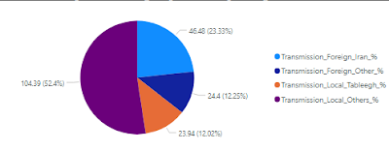](https://www.blogger.com/blog/post/edit/4862903634581934952/940037588416177731)

Here the first visual shows the cases from tableegh and local transmission and the second visual shows the cases from the Iran and other than Iran transmission and the third visual shows the overall percentages of both transmissions.

**5.**   Total Hospitals and their capacity across each Province.

[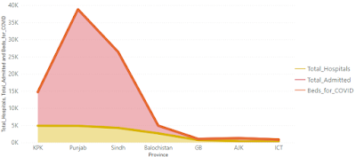](https://www.blogger.com/blog/post/edit/4862903634581934952/940037588416177731)

Here the data is shown about all the capacity of the hospitals in each province.

**6.**   Suspected cases, confirmed cases and death cases in the last date and Last 24 hour's.

[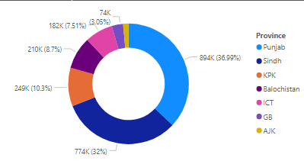](https://www.blogger.com/blog/post/edit/4862903634581934952/940037588416177731)

This shows the overall percentage of total suspected, confirmed and death cases in the last 24 hours and before the previous/last date (you can check all of these cases separately below ).

**7.**    Hospital admitted and home quarantined cases.

[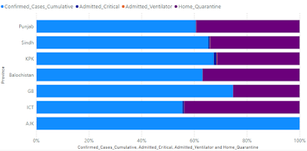](https://www.blogger.com/blog/post/edit/4862903634581934952/940037588416177731)

Here all those cases are shown which are hospital admitted and which are home quarantined.

**8.**    Contact Tracing of travelers (ie returnees from Iran and China)

[[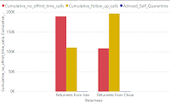](https://www.blogger.com/blog/post/edit/4862903634581934952/940037588416177731)](https://www.blogger.com/blog/post/edit/4862903634581934952/940037588416177731)        [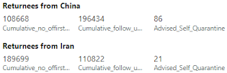](https://www.blogger.com/blog/post/edit/4862903634581934952/940037588416177731)

Returnees from Iran and China's cumulative followup and no of-first calls are shown here.

**9.**    NIH and Province preparedness and response on specific risk.

[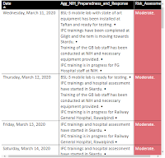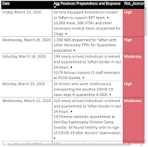](https://www.blogger.com/blog/post/edit/4862903634581934952/940037588416177731)

National Institute of Health (NIH) and Provinces Preparedness and Responses on risk are shown here separately.

**10.** News Timeline for the updates in Pakistan and Globally.

[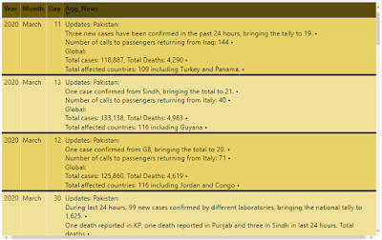](https://www.blogger.com/blog/post/edit/4862903634581934952/940037588416177731)

All the updates of Pakistan and Globally on the Virus are shown here in the news timeline visual.

Below is the complete report showing all the **visuals interactively (refer to .html file named ‘visuals’ provided along with the word file):**

**VIDEO:**

Video of the project is shown below which also shows the **Dashboards**i have made **(refer to the video named ‘video’ provided along with the word file):**



**GIT-HUB REPOSITORY:**

Following is the link for the git-hub repository file:

[**https://github.com/LaibaAbbasi/DATA-VISUALIZATION-FOR-COVID-19-PAKISTAN.git**](https://www.blogger.com/blog/post/edit/4862903634581934952/940037588416177731)

That's all! this was my all work shown to you. Avoid hand shaking and adopt social distancing. Play an active role in fighting corona and be compassionate to people who have corona virus and those who are treating them. They need our respect and care to fight this virus. Hope this pandemic will end soon. InShaAllah! :)